Hardware Used
- Firewall: Netgear SRX5308
- Managed Switch: Netgear ProSafe M4100-D12G
- Camera: TRENDnet TV-IP321PI
- PoE Injector: 802.3af standard injector
- Cabling: 6 × 3ft Cat6 Ethernet cables

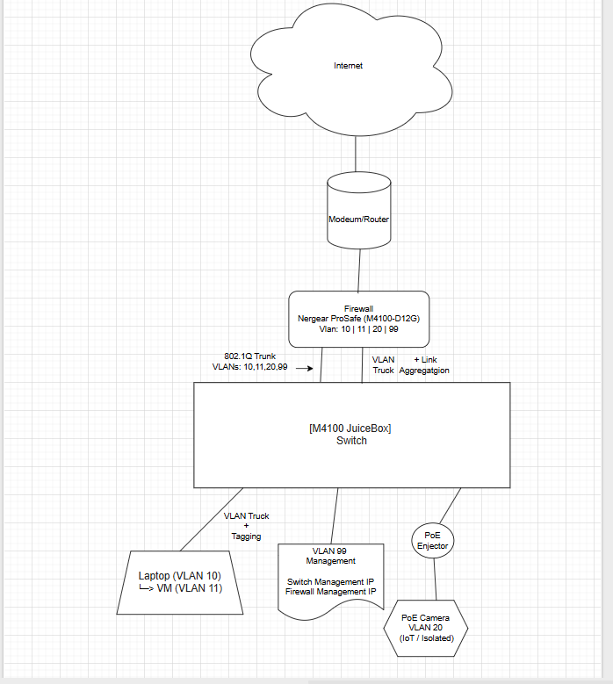

Notes on the Topology
- Firewall:
- Acts as the router and gateway for all VLANs
- Controls traffic with ACLs
- Switch
- Trunk port connects to firewall, carrying all VLANs
- Access ports assigned per VLAN:
> Laptop/VM - VLAN 10 / VLAN11
> Camera - VLAN 20
- VLAN Split
- Laptop/VM cannot talk to camera unless firewall rules allow it
- Camera is isolated: simulates enterprise IoT security
- VLAN 10 and VLAN 11 will be logically separated network segments. Even though they traverse the same physical port, VLAN tagging ensures traffic remains isolated between devices.
- Optional Management VLAN (VLAN 99)
- Can be used for switch/firewall management
- Keeps admin traffic separate

VLAN 99 is configured as the management network, allowing secure administrative access to both the firewall and the switch while isolating management traffic from user and IoT networks.
- Each VLAN has its own Default gateway on the firewall, The IP address that devices send traffic to when they want to reach another network
- Firewall controls routing between VLANs and applies ACLs

Why this is required
- VLANs on the switch don’t route themselves
- Without firewall subinterfaces:
- VLAN 10, 11 and VLAN 20 cannot communicate
- You cannot apply rules to isolate devices (example: camera vs. laptop)
- With subinterfaces:
- You can route traffic between VLANs when allowed
- You can block traffic to enforce security

Vlan Logical Notes:
On an unmanaged switch (no VLANs), all devices are in the same broadcast domain and can communicate freely. On a managed switch (which is what I am using), VLANs separate devices into different logical networks; for example, you cannot locally communicate (ping, file access, network printer etc.) with “neighbor,” “school,” or “hospital” networks in this analogy. The VLANs place each device into its own network segment. Devices in different VLANs cannot automatically communicate unless Inter-VLAN routing is configured through a firewall (in this lab, inter-VLAN routing is handled by the firewall). Simply enabling VLAN routing does not automatically allow local communication with other devices physically connected to the same switch; rules must be defined to control traffic, or else local communication is not allowed.

NIC Notes
Because my VM and PC share the same host NIC, both will travel over the same physical port, carrying multiple VLANs (VLAN 10 + VLAN 11). VLAN tagging is required, it attaches the VLAN number to the packet so that the switch/firewall knows which traffic belongs to which device. This separates my host PC and VM traffic logically, even though they share a single physical NIC.
If the VM had a separate physical NIC, no tagging would be needed; you could assign each NIC to its own access port, where traffic enters and exits separately.

Separate NIC: logical separation is automatic
Shared NIC: logical separation requires tagging

TroubleShooting:

Firewall Configuration (SRX5308)

I want to configure the firewall first because it’s basically the brain of the network. It controls the IP addresses, the VLAN gateways, the routing between VLANs, and the security rules. Since every VLAN needs a gateway IP and that gateway lives on the firewall, it made more sense for me to build the network structure there first. That way, I knew exactly what subnets and VLAN IDs I was working with before touching the switch.
Once I finished setting up the VLAN interfaces, IP addresses, and basic firewall rules, I moved to the switch and configured it to match the design. Doing it in this order helped me stay organized and avoid mistakes. Instead of guessing on the switch and then fixing things later, I built the foundation first and then connected everything

Connect device to computer

IPV4 already selected on firewall

Me making sure both fire fall and PC on the same subnet because they need to be to be able to communicate with each other
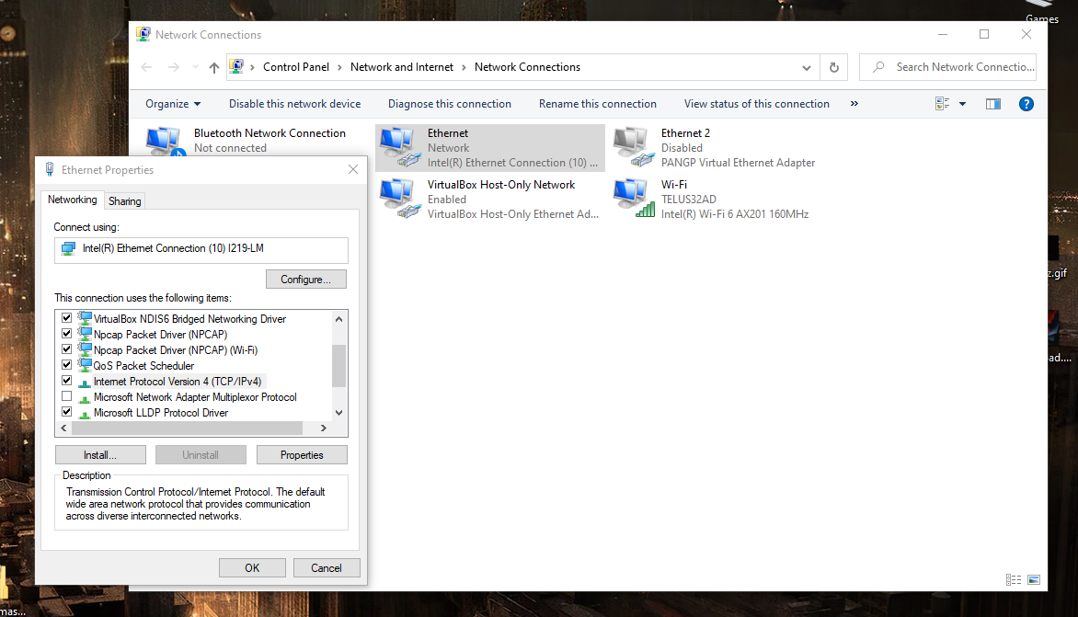
Firewall Default on the back of firewall or can be found:
/https://www.downloads.netgear.com/files/GDC/SRX5308/SRX5308_RM_25Apr2013.pdf

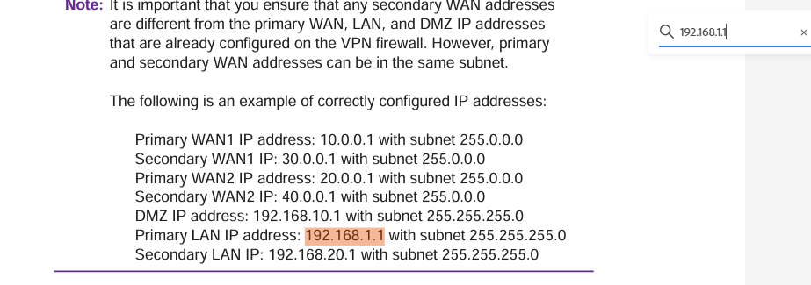

NetGear Firewall
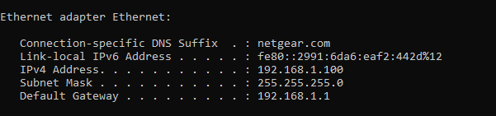

Host PC:
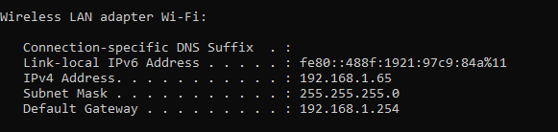

PC can fully communicate with Firewall & on the same subnet
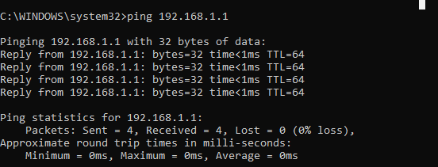

Confirms my PC can reach reach network gateway which is important cause if firewall is acting as gateway for other VLANs, which i will have for future VLANs
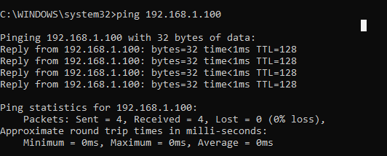

Open BRowser & Log in
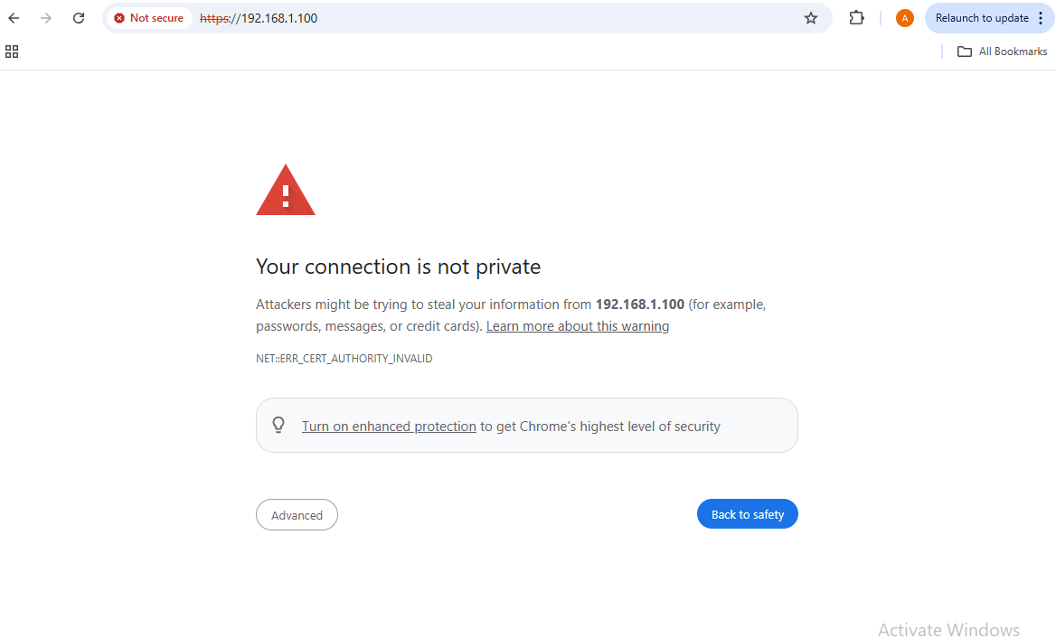
> Above Message meaning Certificate has not been signed by a Certificate Authority

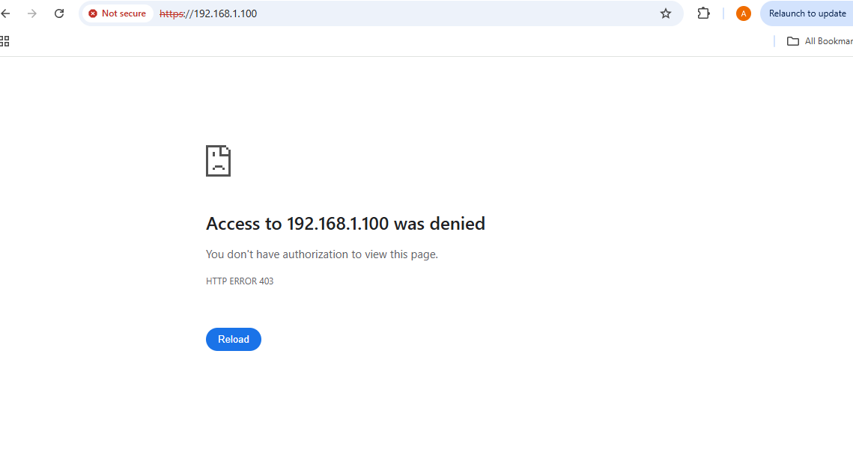

Sometime purchased or used firewalls require exact reset procedure to restore web access

Follow manuel instruction carefully
https://192.168.1.100
- Used the default credentials (usually admin/admin or what came with it from Kijiji).

I encountered a 403 Forbidden error on all browsers. This indicated that the web GUI was still restricted, likely due to partial previous configurations or management access limits. I verified the correct LAN port and performed a full power cycle reset to restore default permissions and IP, ensuring a clean lab environment.

403 is happening:
1. Management access restricted to certain ports or interfaces
- Some firewalls only allow web GUI access from a specific LAN port or VLAN.
2. Reset didn’t fully restore defaults
- Some secondhand firewalls don’t fully reset the web GUI permissions unless you follow a very specific reset procedure (power cycle + hold reset pin).
3. Previous credentials or lockout
- The firewall may still require a username/password that wasn’t reset.

Resting of firewall did not work

Potential Issue:
Wi-Fi being active: Your PC has a second network (192.168.1.65) on Wi-Fi. Windows can sometimes prioritize one network over the other, and your requests may still be going out the wrong interface.
Wifi disabling didn't work

Potential Issue:
Double NAT
Access to the firewall web interface returned an HTTP 403 error. This was likely caused by another router (the Telus router) on the same network acting as a gateway. When multiple routers exist on the same network, routing conflicts can occur and prevent direct access to device management interfaces

Internet - Telus Router (gateway + NAT) - Firewall - Lab network
The Telus router was performing Network Address Translation (NAT) while the firewall was also acting as a routing device. This created a double NAT scenario where multiple gateways existed on the same network segment, which can interfere with direct access to device management interfaces

Bridge Mode
Bridge mode allows a device to pass network traffic directly to another router or firewall without performing routing or NAT. The device functions as a simple network bridge rather than a gateway.

> Bridge mode forwards traffic without performing routing or NAT. It was attempted in this lab to determine whether the ISP router was preventing access to the firewall management interface.

In this setup below: enabling bridge mode on the ISP router was in hope to allow the firewall to receive the public IP address and handle routing instead of the ISP device.

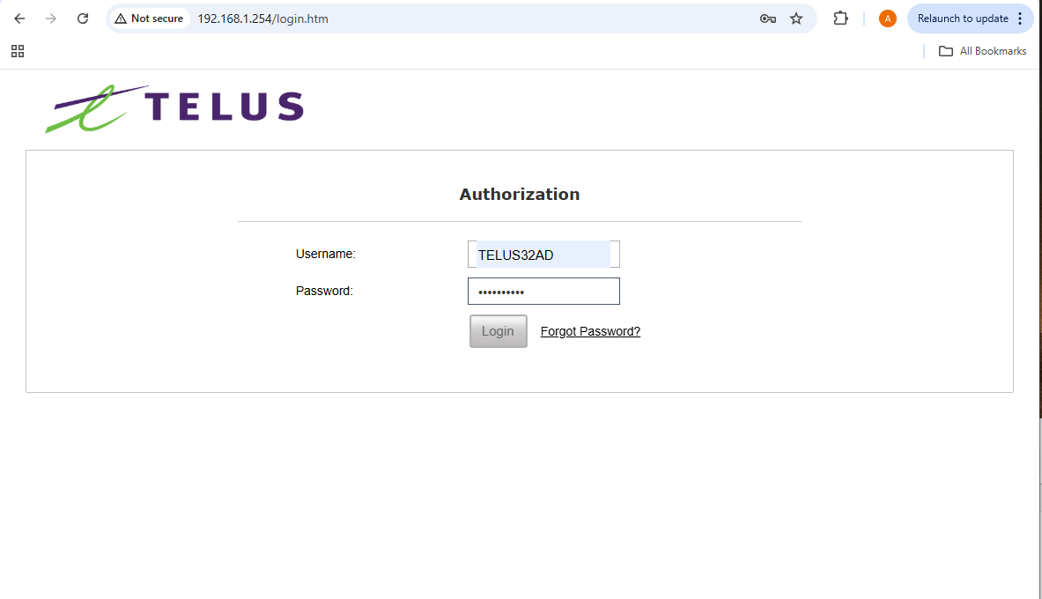
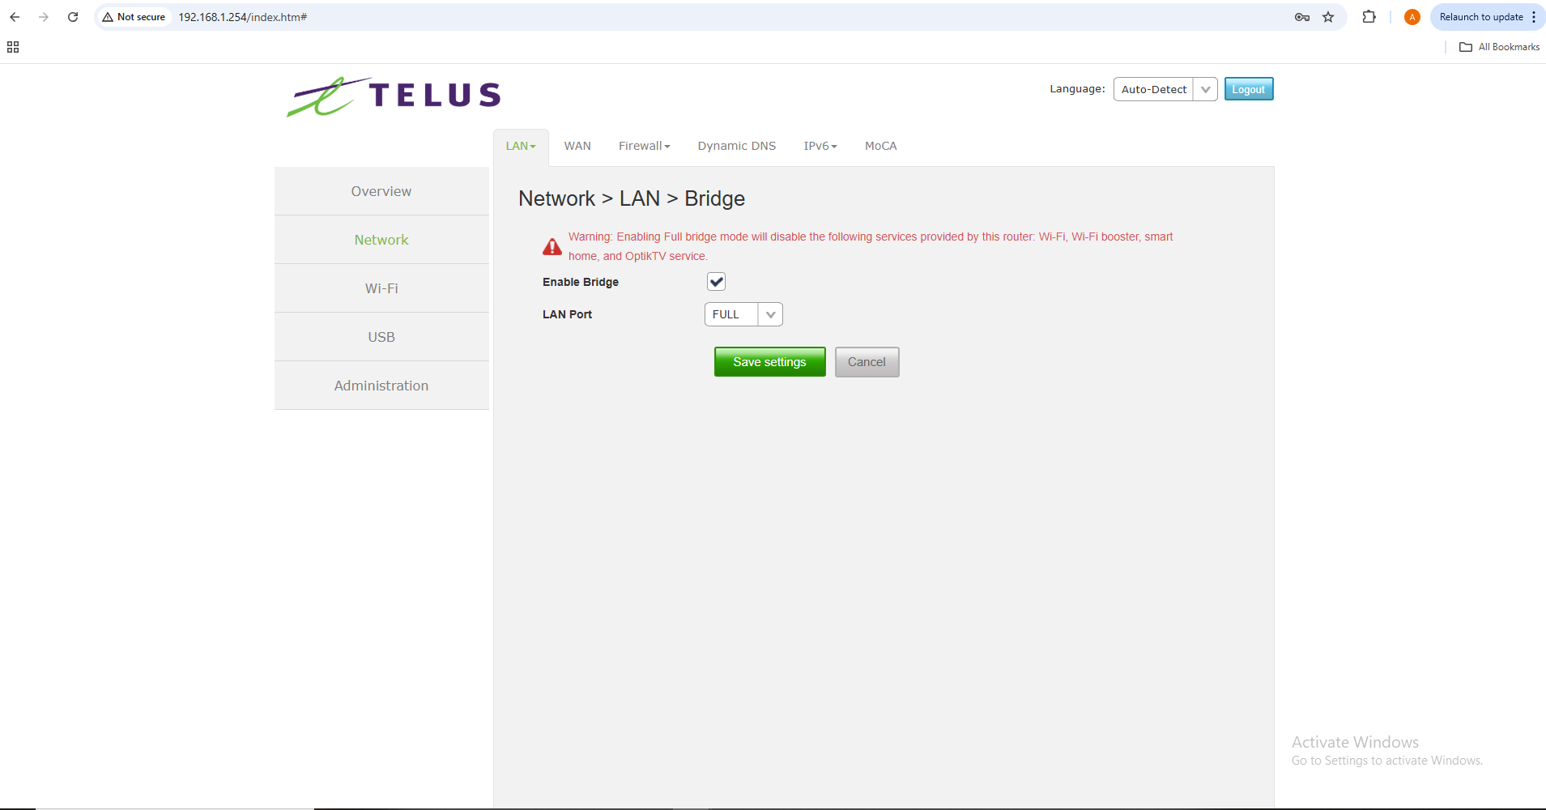
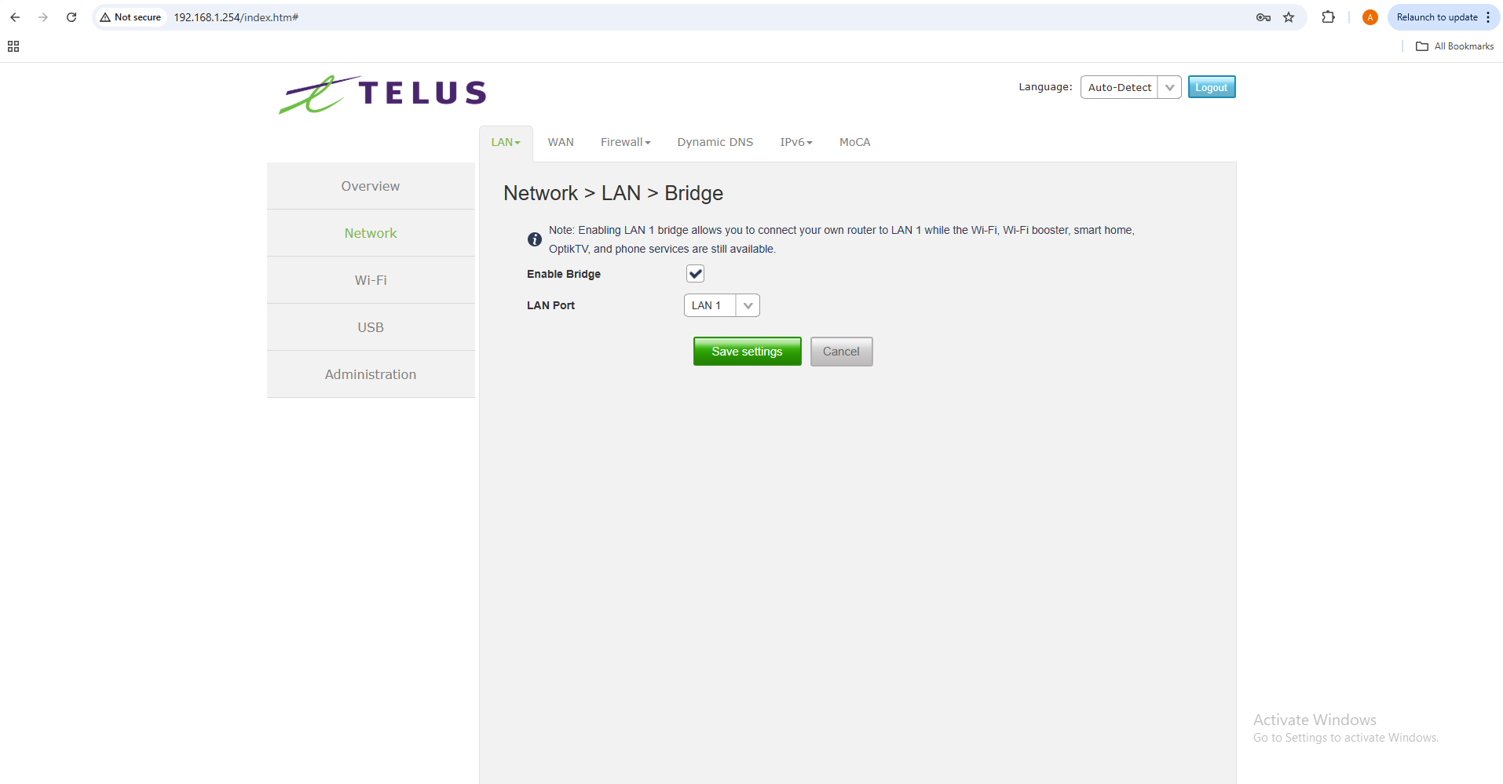

Bridge Modem:

- Don’t bridge the modem unless you really Just plug the firewall WAN into the modem/router as-is.
- Your lab VLANs, inter-VLAN routing, and PoE devices will work fine behind the modem/router.
I chose not to bridge my modem because I don't want the firewall to act as the full gateway to the internet. I wanted the firewall to focus solely on controlling and protecting my internal network. By reverting to keep the modem in its standard mode(No bridge), the firewall will still manage all VLANs, inter-VLAN routing, and firewall rules, ensuring that all devices: laptop, VM, switch, and PoE camera are segmented securely and the traffic flows according to my design.

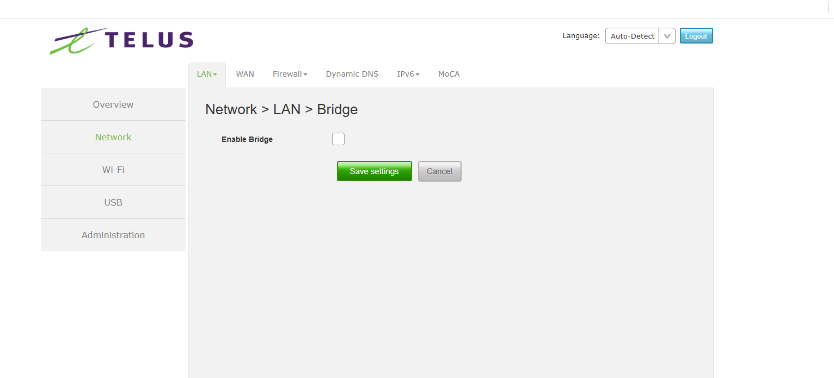

Even though the firewall isn’t directly exposed to the public IP, it still enforces security and controls communication between devices and the internet, which aligns with my lab goal of learning enterprise-style network protection and traffic management.
This approach reflects a deliberate design decision: the firewall’s role is to govern and secure the internal network, not simply act as the network edge. It allows me to focus on testing routing, VLAN segmentation, and security policies in a controlled environment, which mirrors how enterprise networks often isolate internal security from direct internet exposure.

Hypothesis:
Because if my firewall LAN is still 192.168.1.x and Telus LAN is also 192.168.1.x, I can still be having subnet confusion
Even though I have enabled LAN1 bridge, my firewall LAN is still overlapping with the Telus subnet. That causes:
- ARP confusion
- Routing ambiguity
- Weird 403 / access behavior
- Devices not knowing which 192.168.1.1 to

Why Can’t Access the Web GUI
Firewall LAN IP = 192.168.1.1, which conflicts with the Telus router subnet you previously had, the firewall may still be confused internally because the management interface expects traffic from a different IP range.

Solution (Planned)
Because the firewall LAN overlaps with the Telus router subnet, I cannot access the web GUI directly. I will use a console cable to connect to the firewall and reconfigure the LAN IP to a non-conflicting subnet. This will provide out of band access, bypassing the network conflict.
I attempted to resolve the LAN overlap by [temporarily changing the firewall LAN IP]. This approach did not work as expected, likely due to the subnet conflict with the Telus router.
The planned solution remains to use a console cable to gain out of band access and reconfigure the firewall LAN IP to a non-conflicting subnet / simply access the firewalls web interface directly; This will allow full access to the management interface and proper network operations once the hardware arrives.proper network operation can be established

Switch SETUP/ configurations

Setting Up:
- VLANs (for your devices like laptop VM and PoE camera)
- Access vs trunk ports
- PoE settings (for the camera)
- Port aggregation if your lab calls for it

Un-resolved Issue
Pc is not seeing switch:

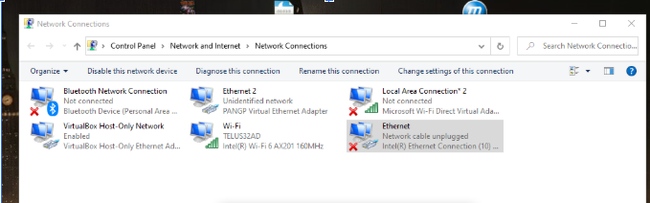

- Cable work and are tested = Work well
- Switch Ports test: lights were on, only when camera plugs & Router plugged (Not PC)
- Laptop port was tested = works with firewall & Router for ethernet

Potential Issue: Layer 1
This is almost my laptop’s Ethernet port not negotiating the link with that switch.

Why this can happen
Laptop Ethernet ports could:
- Partially fail;
- Have damaged pins
- Have driver corruption
- Have speed/duplex stuck incorrectly
- Have power-saving settings interfering

Technical Observation
I can connect to the firewall (just can’t access webpage)
> NIC does work.
Not a dead port.

Potential Issue:
- Auto-negotiation mismatch
- Port speed issue
- Or rare case: switch port locked to specific speed

Force Speed & Duplex
Device Manager:
Network Adapters
Right-click your Ethernet adapter
Properties
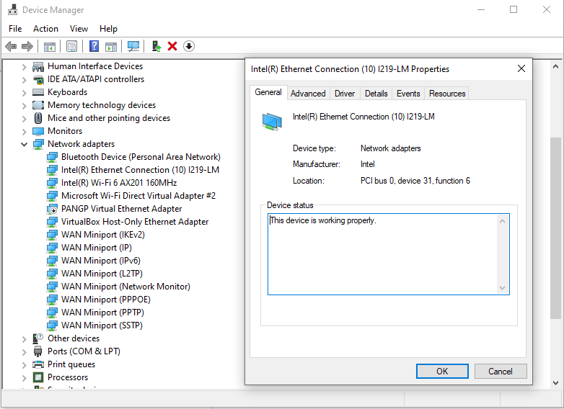
Advanced tab
Looking for:
Speed & Duplex
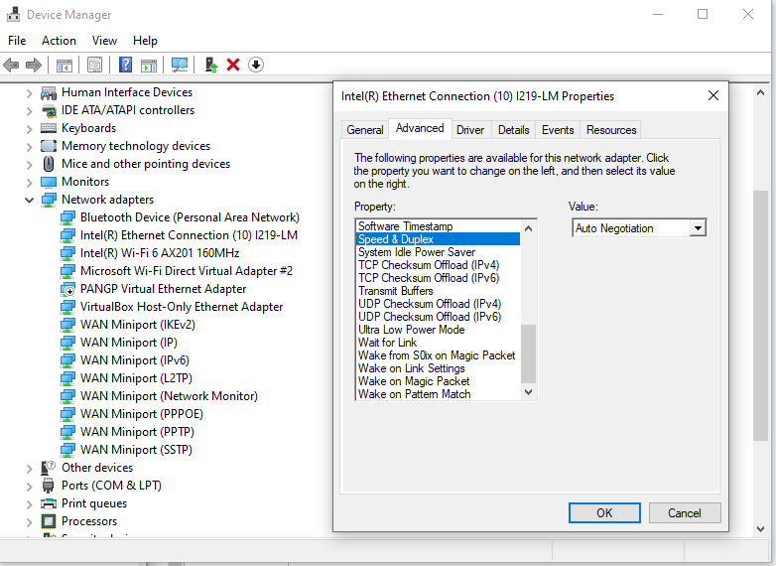
- Auto Negotiation

Changed it to:
1.0 Gbps Full Duplex
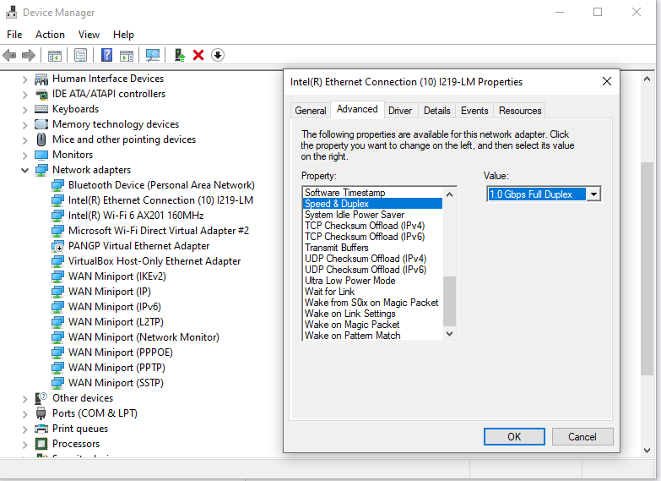

Unplugged and repluged the cable into the switch.
> No lights appeared

Changed to:
100 Mbps Full Duplex
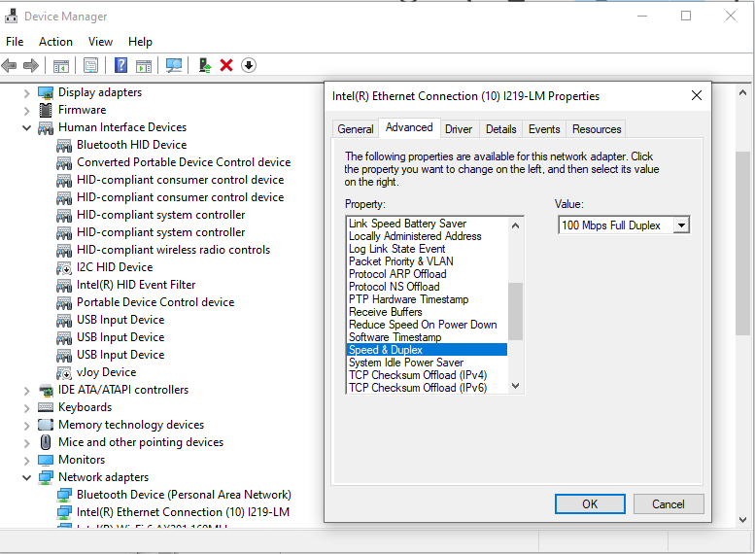

Tried forcing negotiation manually. = Cant see switch

Troubleshooting Step: Speed & Duplex Override
When I initially plugged my laptop into the managed switch, the connection showed no link on either side(both PC and Switch). My first step was to address auto-negotiation issues, which can sometimes prevent the physical link from coming up. In the NIC properties, I found Speed & Duplex was set to Auto Negotiation, meaning my laptop would automatically try to agree on a connection speed with the switch.

To test if a negotiation mismatch was the problem, I manually set Speed & Duplex to 1.0 Gbps Full Duplex, which is a common high-speed link used in labs. When that did not bring the link up, I tested 100 Mbps Full Duplex, because many managed switches or older hardware will default to 100 Mbps and may not negotiate properly with a laptop trying 1 Gbps.

mismatched speed and duplex between devices could result in no link, slow link, or packet loss. Even though the manual settings did not resolve the issue, this standard Layer 1 troubleshooting technique ensures that negotiation mismatches are eliminated as a possible cause

Disable Power Saving
In the same Ethernet adapter > Power Management tab
Uncheck:
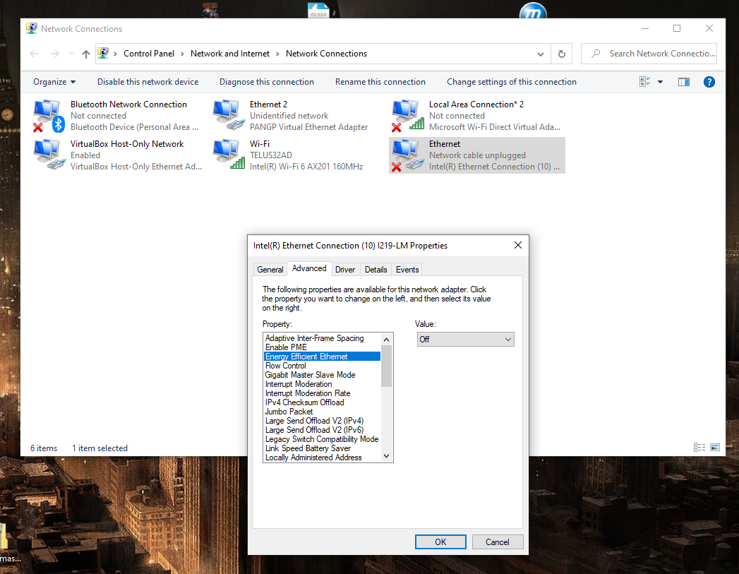
Allow the computer to turn off this device to save power
Apply.
Test again = Pc still cant find switch
Disabling the network adapter’s power-saving setting ensures the NIC remains fully active, preventing link detection issues between the PC and switch
Network adapters may use a power saving features to reduce energy consumption. When enabled, the adapter may lower power to the Ethernet port or temporarily disable the interface when it detects little activity. This can interfere with the physical network link, preventing the PC and switch from detecting each other. Disabling the power-saving option ensures the network adapter remains fully active and maintains a stable connection.
Managed switches might not don’t like the NIC reducing power, and auto-negotiation fails, which can looks like a dead port

Notes:
- Your laptop Ethernet NIC works (you can connect to the firewall and other devices).
- Your cables are good (tested with other devices).
- The switch is powered on.
- Laptop ↔ Switch = no link at all, while other devices do show link on the same switch an laptop ports.
- Already tried: forcing Speed & Duplex and disabling Low Power Modes.

> Eliminated: Layer 1 and NIC issues, and it’s looking like:
- The switch port might be misconfigured or damaged.
- Or the switch itself has some internal issue preventing it from linking with your laptop NIC.
Since it’s a managed switch, it’s also possible the ports are administratively shut down or locked to certain speeds/VLANs that your laptop cannot access without console access.

Options from here
- Get a console cable for the managed switch
- Then log in and check/enable the port, reset it to factory defaults, or assign the correct VLAN.
- Use a different switch (or an unmanaged switch)
- A simple unmanaged switch guarantees plug and play connectivity for your lab.

—--------------------------------------------------------------------------------------------------------------------------

> Console Cable: On they way/In progress

